People's Democratic Republic of Algeria
Ministry of Higher Learning and Scientific Research
Abderrahmane Mira University, Bejaia
The Faculty of Economics, Business and Management Sciences (FEBMS) in
collaboration with the Laboratory of Economics & Development is organising
on the 15th and 16thof June 2020, the first international conference devoted to:
The Informal Economy and Gender Inequalities

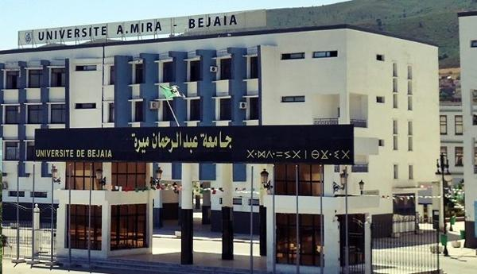
Chairwoman of the conference: Dr. Hassiba Gherbi
PhD in Economics, Universites of Bejaia (Algeria) and Paris-Est Créteil (France).
Honorary Chairmen: Pr. Boualem Saidani, Rector of Abderrahmane Mira University, Bejaia
Pr. Kamal Oukaci, Dean of the FEBMS, Abderrahmane Mira University, Bejaia

Call for papers
The informal economy encapsulates informal employment of the workers in the informal sector, the formal sector and households, who do not benefit from social protection (ILO, 2013, Charmes, 2019). It plays a significant role with respect to job and wealth creation in the MENA countries, wherein it accounts for over half the total of non-agricultural employment (ILO, 2018), but this role is controversial in terms of development. The informal economy exerts a negative influence, regarding low level of productivity and high precariousness of the jobs created, as well as a substantial tax shortfall and a duality in the business environment that endangers the regulatory framework. The informal economy, however, generates jobs and incomes, acting as a safety valve for the least protected segments of the population.
The labour market segmentation dividing formal and informal employment goes hand in hand with an income gap (wage gap) between the men of employed women. Women in North Africa make up on average less than a quarter of the urban labour force, which is one of the lowest rates in the world (World Bank, 2018). Despite a much lower participation rate in labour force, women participate in informal activities at least as much as men (ILO, 2012). In Algeria, the rate of informal female employment (24%) in the private sector is higher than that of men; in Egypt, as in Tunisia, over a quarter of employed women work in the informal sector.
Statistics most often underscore the contribution of women to the informal economy, including within the household, in terms of employment and output as well as income. Since these activities are partly home-based, they are not easily measureable, nor are they investigated or valued as such.
This conference intends to provide a state of the art of the informal economy in Algeria, North Africa and other countries of the MENA region. It will tackle various topics and use different investigation methods. It is part of a gender approach, which aims at identifying the place of women on the labour market in these countries, whereby access to employment allowing them to conquer rights and gain social inclusiveness.
Comparative analysis is strongly encouraged. The communication of this conference will be able to mobilize earnings functions, quantile regressions upon the income distribution and Oaxaca-Blinder models of decomposition, as well as (quasi) experiments of the "before-after" type, with (propensity score) matching and counterfactual, according to gender divide and the formal/informal employment segmentation.
The conference will discuss orientations towards the formalisation of the informal sector and informal employment (taxation, regulation and social protection), as well as gender inequalities on the labour market, with respect to a transition to the formal economy.
Research topics
Contributions will include but are not limited to the following topics:
1. The various approaches (dualist, structuralist, institutional, etc.) as regards the scope, trends and participants of the informal economy: controversies and converging views.
2. Relevance and completeness of measures (direct vs. indirect methods) of the informal economy: Surveys (households vs. enterprises), national accounts and computable general equilibrium, econometric modeling.
3. The determinants of access to the informal sector and informal employment: voluntary choice vs. last resort? What may explain differentiation between men and women: human capital and preferences on the labour supply side and/or profiles requirements on the labour demand side?
4. Female informal wage employment and male / female income differentials: are they industry driven?
5. Informal entrepreneurship and gender: to what extent do aspirations vs. constraints differ?
6. The transition from the informal to the formal economy: tax relief, simplification of regulation and / or extension of social protection? Which devices with respect to efficiency, fairness and costs? Should there be positive discrimination towards women?
Scientific Committee
M. Achouche (Bejaia), P. Adair (Paris Est Créteil, France), J. Ait-Soudane (Rabat, Maroc), A. Belkacem Nacer (ENSSEA, Alger), R. Boudjema (ENSSEA, Alger), Y. Bellache (Bejaia), C. Bounoua (Tlemcen), O. Babou (Tizi-ouzou), M. Bouznit (Bejaia), S. Boumoula (Bejaia), M. Boukrif (Bejaia), J. Charmes (IRD), D. Coletto (GliStudi di Milano-Bicocca- Italie), H. Gherbi (Bejaia), F. Kern (Strasbourg, France), M. Kertous (Brest, France), M. Lassassi (CREAD), D. Musette (CREAD), M. Musette (CREAD), A. Mouhoubi (Bejaia), K. Oukaci (Bejaia), A. Souag (Mascara), F. Talahite (CRESPPA-CNRS, France), A.Tansel (Ankara, Turquie), H. Zidouni (ONS).
Steering Committee
M. Amghar, O. Amir, M. Aroun, A. Alilat, M. Azougui, L. Berkouk, B. Bekka, T. Benmouhoub, B. Gana, I. Hammache, N. Imadaly, S. Kaci, R. Medjmedj, M. Mahmoudi, D. Rézki, H. Touati, H. ZidelKhil, R. Zidat.
Schedule
Deadline for submission of communication proposals: January 31, 2020
Date of the Scientific Committee Decision: 28 February 2020
Registration deadline: April 28, 2020
Deadline for sending the full paper: 28 April 2020
Deadline for sending the final program of the conference: May 28, 2020
Beginning of the conference: May 15, 2020
Proposals should be submitted no later than 31 January 2020 in a two-page Word document containing the following information:
• An abstract of 1000 words (including title, text, list of keywords and five major references).
• Name and surname of the author and co-author (s) of the communication, professional status, contact details (Email, mobile phone), institutional affiliation.
• Abstracts should be submitted in English, French or Arabic.
• Communication can be presented in English, French or Arabic.
Abstracts will be assessed by the Scientific Committee. Authors whose abstract is selected should submit their full paper (8,000 words maximum and 16 single spaced pages)no later than April 28, 2020.
After the conference, a selection of papers will be proposed for publication in Cahiers du CREAD or in an Anglo-Saxon journal (e.g. European Journal of Comparative Economics, European Journal of Development Economics or Middle East Development Journal).
Overview of the wilaya of Bejaia
The wilaya of Bejaia is located in the North East of Algeria, in the region of Kabylie on its Mediterranean coast. It gave its name to candles. It is from Bejaia that Arabic numerals became popular throughout Europe. Bejaia enjoys many natural sites and historical relics, which still bear witness to the splendor of its long history. Its urban fabric is characterized by an uninterrupted continuity of occupation since the highest antiquity. It has a large industrial center, an important port and an international airport.
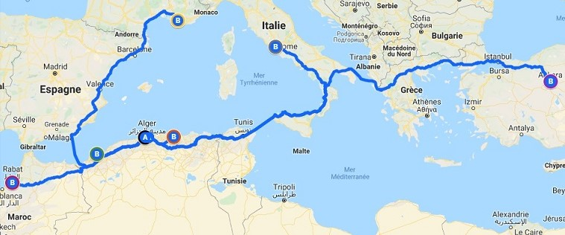
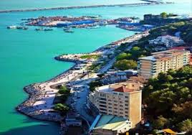

Registration Fees
Conference registration fees cover documentation, coffee breaks, lunches, dinners and accommodation. These fees are:
• 8000 Algerian dinars (100 Euros) for lecturers and professionals;
• 4000 Algerian dinars (40 Euros) for PhD students.

Abderrahmane Mira University, Bejaia
The Faculty of Economics, Business and Management Sciences
In collaboration with the Laboratory of Economics and Development
1st International Conference
The informal Economy and Gender Inequalities
Aboudaou Campus, June 15th and 16th 2020

COMMUNICATION PROPOSAL
First Name: Name:
Institutional affiliation: Discipline:

 PhD student  Lecturer/Researcher  Other (please mention):
Professional address:
Cellular phone:
Email:

Abstract enclosed hereafter (2 pages and 1,000 words: title, keywords and five major references).
Presentation of the communication in: French  English  Arabic 
Please send back no later than January 31st 2020 to the following address:
Contact: informel.genre@gmail.com
Tel: +213 55995 4023

